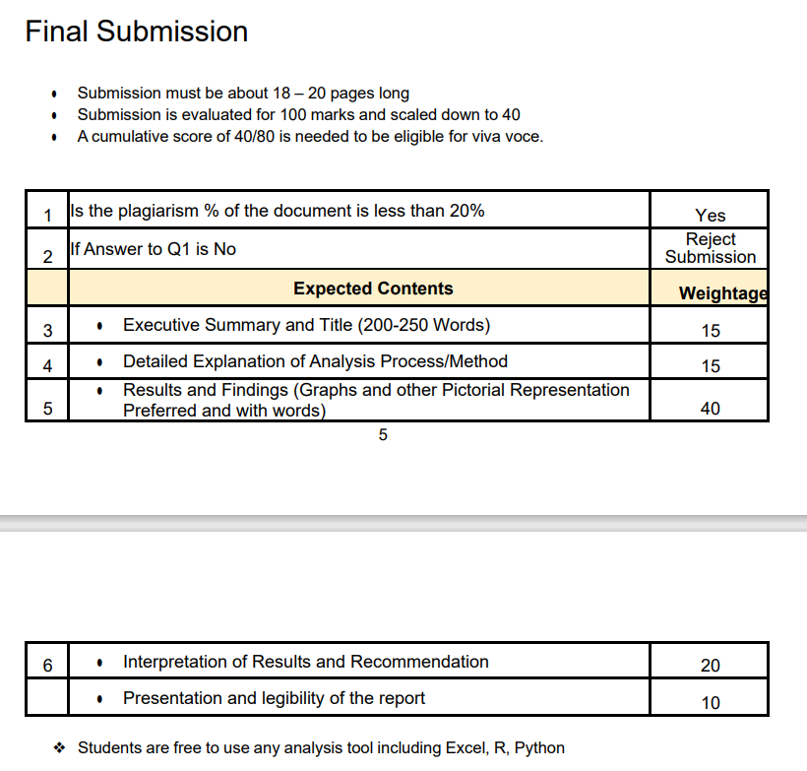

Note :

1. Include self declaration

TA Comments: Declaration statement is missing from the report. You must add a declaration statement with your signature in your next submission; otherwise, your report will be rejected. The executive summary is too long. The executive summary should be concise and provide a clear overview of the report's key points. It should not exceed the 200-word limit. In the proof of originality section, you should include a video of the conversation with the owner and a link to the collected data. One or two photos are sufficient for proof of originality. In the descriptive statistics section, interpret the statistics provided. In the analysis process/method section, you should provide details of all statistical analysis used, not just linear regression.